**Venue: ADD VENUE**

**All welcome!**

**Tea and Coffee will be served**

**Find out more about ADD SUBJECT!**

**Date:** **ADD DATE**

**Time:** **ADD TIME**

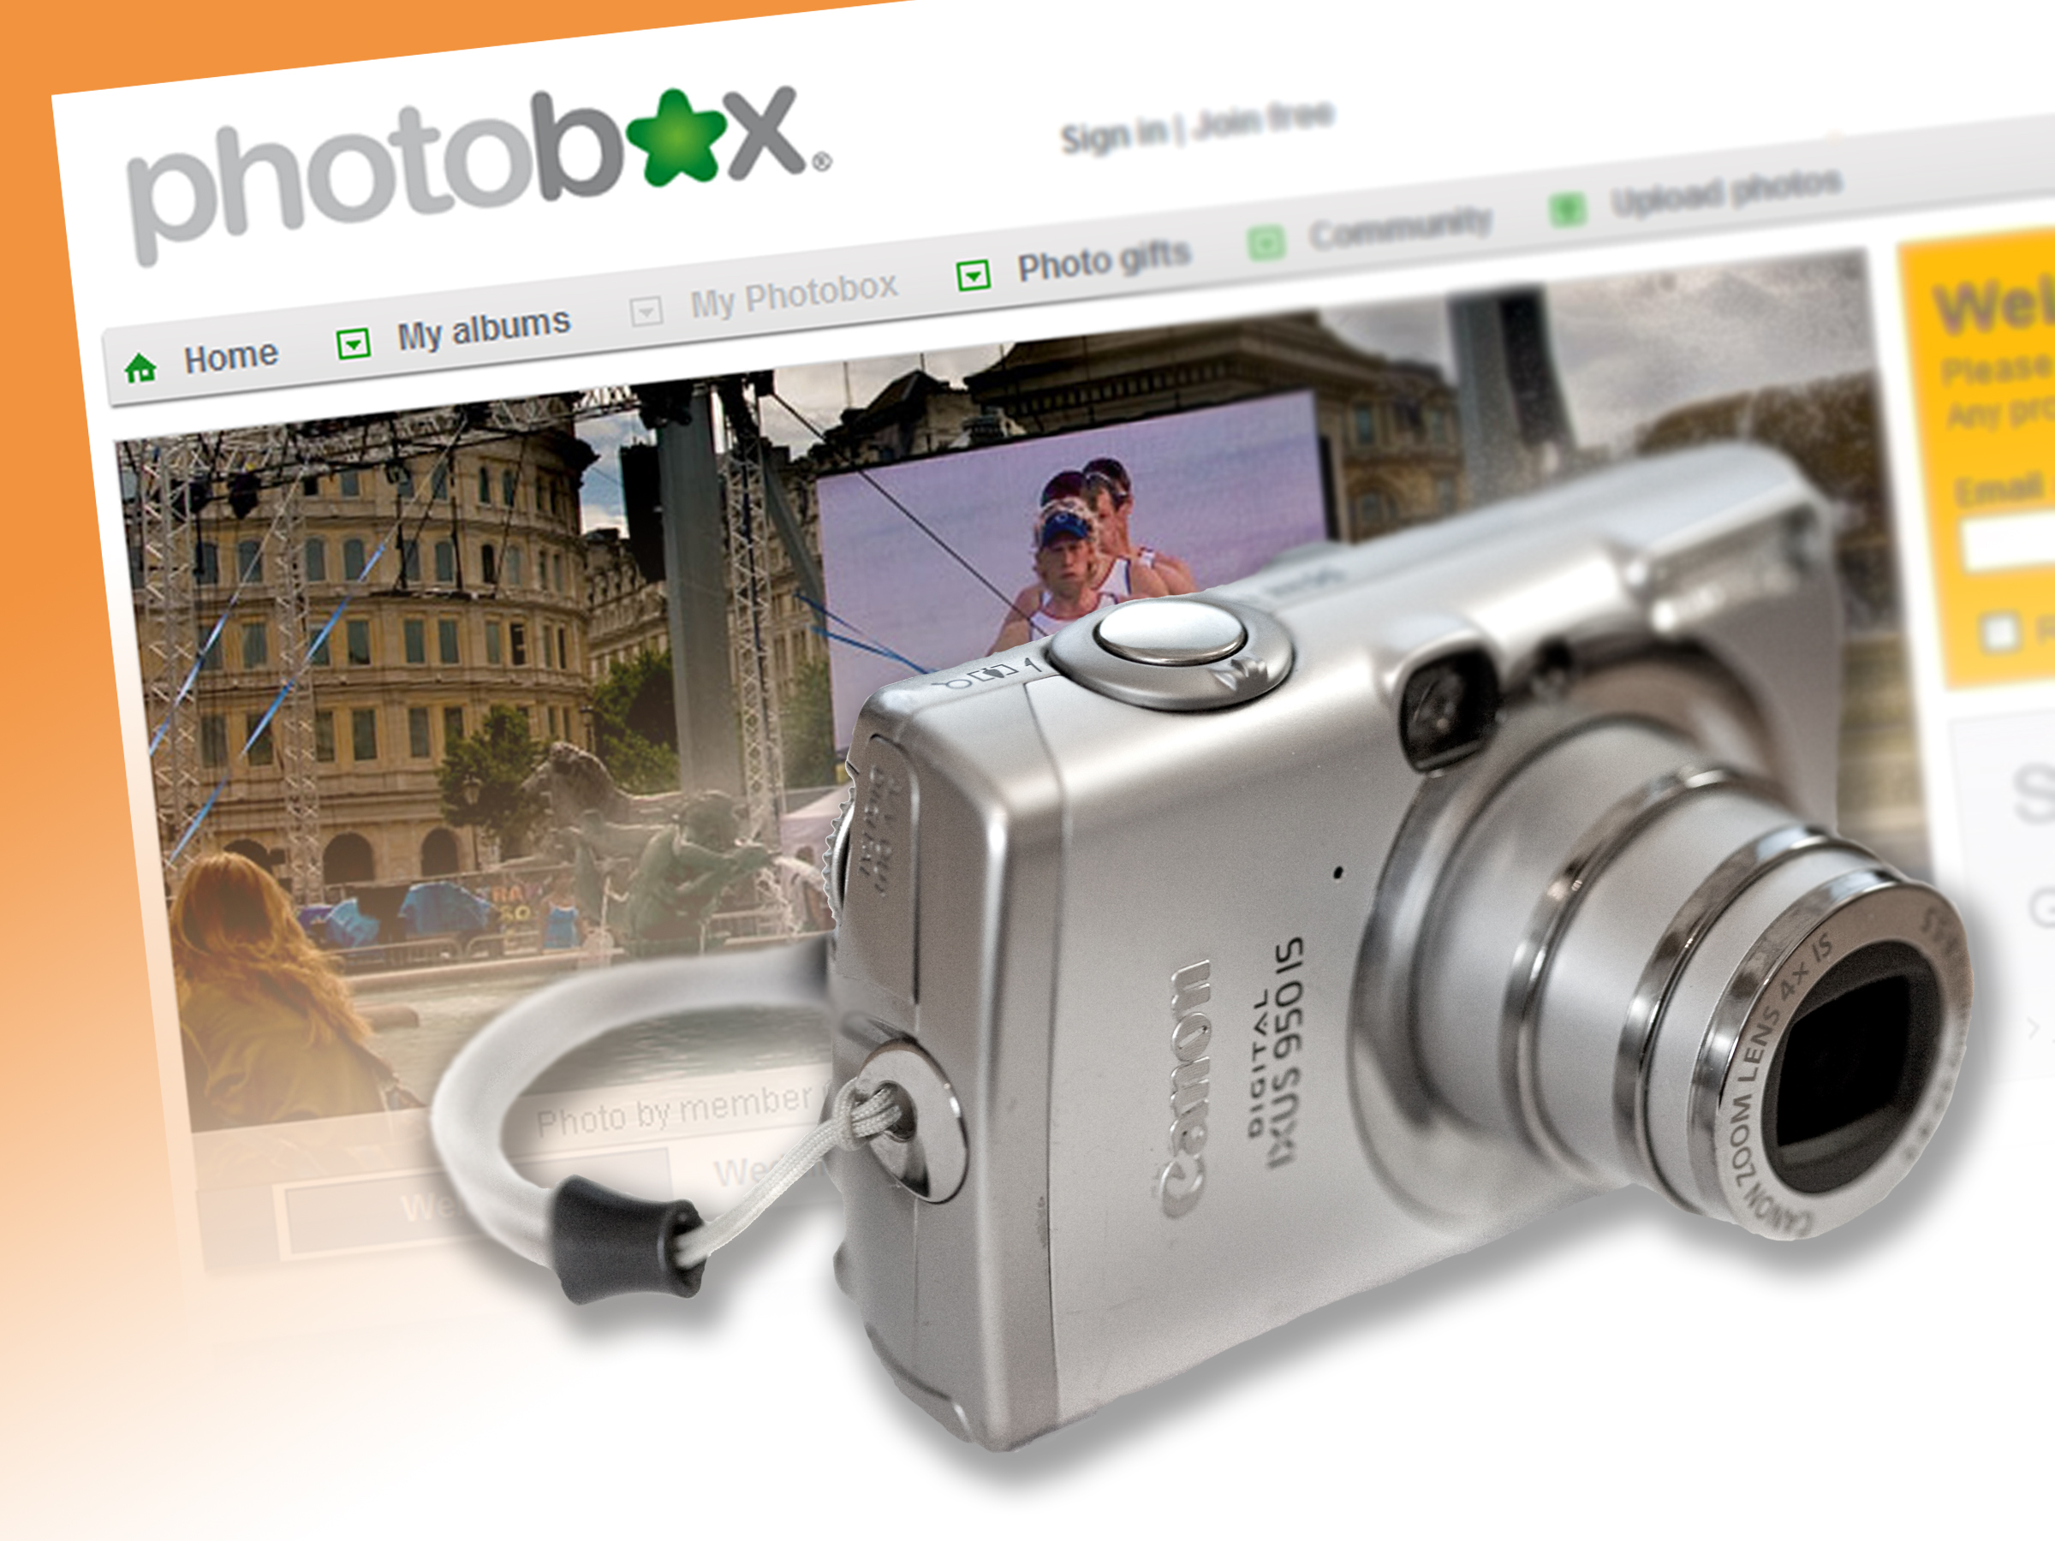

**How to insert the picture and add the special rotation and effects:**

1. **Add a** text box (like this one): **Go to** Insert menu, **click** on “Text Box”, then draw the text box on your page.
2. **Double click** on text box and set the “Shape Outline” and “Shape Fill” to None.
3. Click inside text box, **go to** “Insert“ tab and **click** on “Picture”.
4. **Browse** to find the image or photo you would like to use.
5. Position the image: **click** on the edge of the text box and use the *arrow keys* to move the text box into the right position. **Click and drag** the image to resize it, if necessary.
6. **Double click** on the image to select it and view the “Picture Tools” in the menu bar.
7. Go to the “Format” tab and **click** on the required picture effect to apply it: the one you want is the seventeenth one from the left. This will skew your photo and apply a drop shadow.



**Add presentation title here**

5C0310

© Computer Sharing Centre Ltd 2010 | www.computersharingcentre.com